**Lab no 10**

|  |  |
| --- | --- |
| Topic | Data mining technique: association rule analysis |
| Objectives | * To learn Data mining using Microsoft Azure Machine Learning Studio. * To perform association rule analysis using Apriori algorithm in Microsoft Azure ML Studio. |

**Class Task:**

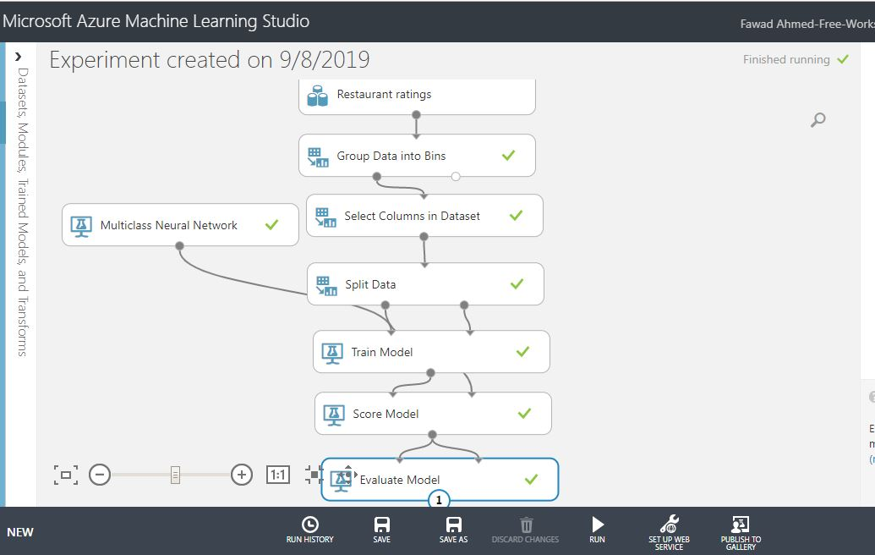

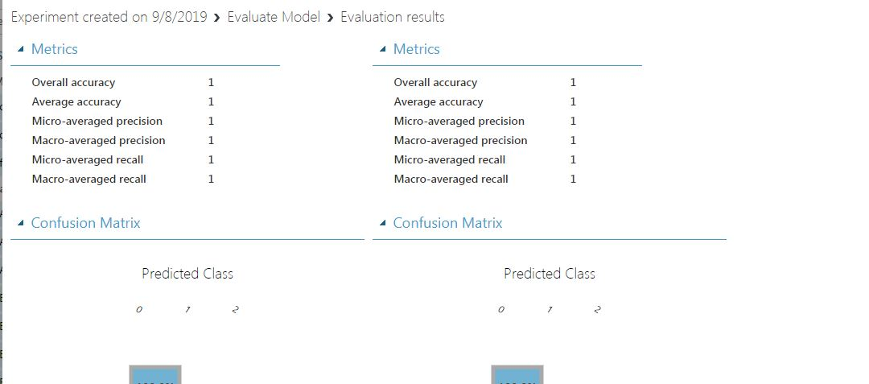

**Task:2(lab task)**

Take any dataset in CSV format and derive association rules and frequent item sets from it using any one of the approaches described above.

